International Research Seminar –
Quality of Life in the Changing World

Organized by:
Laboratory for Comparative Research in Quality of Life, TSU
International Laboratory of Positive Psychology of Personality and Motivation, HSE

AKTRU (REPUBLIC OF ALTAY) – 2018
1. GENERAL INFORMATION
The Research Seminar is aimed at analysis of the phenomenon of life quality in connection with global and local social challenges and natural climatic zones.
Main tasks of the Seminar:
- Analysis of the best practices of complex interdisciplinary research of life quality concept;
- Development of the concept of life quality interpretation in communities of Siberia and Arctic;
- Studying the influence of the natural environment and landscape on the level of subjective wellbeing and recreational potential of the individual;
- Development of the road map for interdisciplinary research of life quality (Foresight session);
- Approbation of the methods for monitoring the quality of life of the population.
As a result of long term research in Tomsk State University, the concept of the image of Western Siberia was formed as a unique "natural mega-facility", 3000 km long, comprising all natural zones – from the mountains of Southern Siberia to the tundra zones of the deep Arctic. Participants of the Seminar are offered an efficient format of creative activity in the ecological zone to build research communication and articulate predictive concepts of interpretation the life quality phenomenon, taking into account the interaction between man and nature, man and technology, social institutions in the changing world using the methods of the humanities and social sciences.
The Aktru research station is located in the highlands (at an altitude of 2150 m) in the southeastern part of the Altai Republic, in the immediate vicinity of the borders with Mongolia and China in the center of the Eurasian continent (50 ° 06'03 "N, 87 ° 40'14" E) . The natural landscape of the area combines mountain slopes, a forest belt, a high-mountain belt with alpine landscapes and glaciers, a high-mountain tundra, and a cryophytic steppe landscape. The nearest town Gorno-Altaisk is 250 km in the north-west direction; the nearest settlement is the village Kuray - located 30 km southeast of the station. Special vehicles transportation will be organized from Kuray settlement to Aktru research station.

- Working language - Russian (English)
- Reports of leading scientists, project sessions, presentation of scientific results in studying the quality of life (psychologists, sociologists, economists), approbation of methods for monitoring the quality of life, conducting sociological surveys
- Seminar participants will receive TSU and HSE certificates
2. ACCOMODATION
- The station has wooden living houses (capacity 70 people) and tent camp (capacity up to 200 people)
- The territory of the station hosts a canteen, a sauna and a shower, a medical center, amenities
- Permanent power supply, Internet access (scheduled)
3. KEYNOTE SPEAKERS
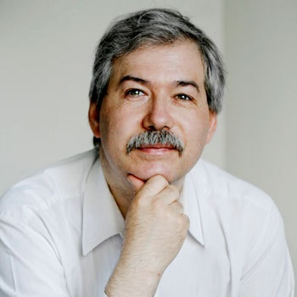 | Dmitry Leontyev – doctor of psychology, professor, head of the International Laboratory of Positive Psychology of Personality and Motivation, National Research University Higher School of Economics, director of the Institute for Existential Psychology and Creative Life (Moscow)
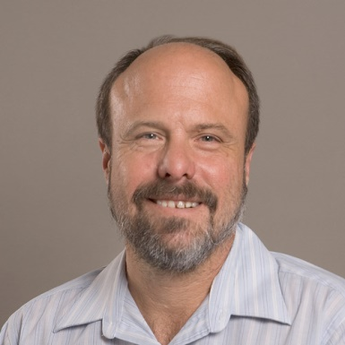 | Kennon Sheldon – doctor of psychology, professor, academic supervisor of the International Laboratory of Positive Psychology of Personality and Motivation, National Research University Higher School of Economics; professor, University of Missouri (USA)
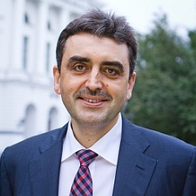 | Eduard Galazhinsky – doctor of psychology, professor, full member of the Russian Academy of Education, rector, National Research Tomsk State University (Tomsk)
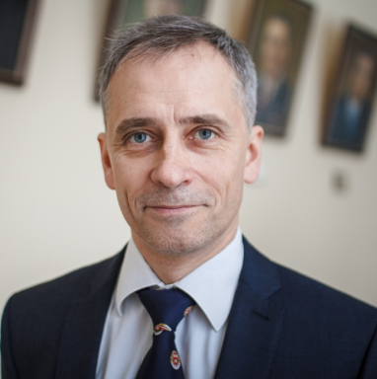 | Artyom Rykun – doctor of sociology, professor, vice-rector for international affairs National Research Tomsk State University (Tomsk)
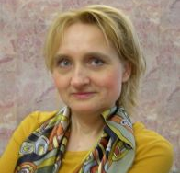 | Tamara Gordeeva – doctor of psychology, professor, leading research fellow of the International Laboratory of Positive Psychology of Personality and Motivation, National Research University Higher School of Economics (Moscow)

4. SEMINAR PROGRAM AGENDA
I. Plenary reports of the keynote speakers:
- Quality of life under uncertainty: the practice of mindfullness
- Anthropological prerequisites for subjective well-being: the image of a personality and well-being based on positive psychology
- The quality of human life in the aspect of evolutionary and cultural psychology
- The world best practices of interdisciplinary research on the quality of life
- The ratio of subjective and objective quality of life factors
- Best international practices of inter-agency cooperation for providing a better quality of life for the population: resources and risks, opportunities and constraints

II. Project sessions:
a) Quality of life and professional development:
- standards of life satisfaction of a modern specialist
- expected quality of life of the future specialist
- planning a career path in the context of achieving individual quality of life standards
- life quality of specialists of different ages

b) Quality of life: issues and problems of measurement:
- algorithms for correlating the indicators of objective and subjective factors of the quality of life
- universal and specific indicators of the subjective and objective quality of life
- biological and social aspects in quality of life and subjective well-being of a person

c) Quality of life: risks and challenges of the changing world:
- perception of the habitat (urban environment) as a predictor of professional activity and territorial mobility of the future specialist
- quality of life and the problem of risk management: the correlation and contradictions
- quality of life thanks to and despite the circumstances

d) Reflective networking (daily to sum up the results)
Technologies for managing subjective and objective factors of the quality of life: practical relevance for social development of the territories, bottlenecks and overcoming strategies

III. Pilot research of the subjective characteristics of the quality of life for the development of empirical hypotheses on the following groups:
- native inhabitants of Altai;
- seminar participants;
- participants of the Alp Art Festival.

Methods of pilot research of integrative analysis of subjective and objective quality of life factors:
• Focused interview
• Focus group
• Projective methods
• Open questionnaires
• Semi-structured interview based on methodology of M. Chikszentmihayi
• Associative method with the use of the visual stimuli (landscapes)

- SEMINAR SCHEDULE OVERVIEW

June 04  Monday | 18.00 – Meeting of the participants and departure by bus on the route Tomsk – Gorno-Altaysk – Kuray. TSU delegation
June 05  Tuesday | 00.10 – departure of the flight Moscow – Gorno-Altaysk. HSE delegation  08.25 – arrival to Gorno-Altaysk  Transfer to tourist complex “Manzherok” – 15 km, accommodation  09.00-10.00 – Breakfast  Repose, acclimatization  13.00-14.00 – Lunch  14.00-17.00 – Excursion  17.00-18.00 – Information on the Seminar agenda and program. Goal setting for work  Moderators: Liudmila Borilo, Valeria Petrova  Research of the subjective factors of quality of life  18.00-19.00 – Dinner
June 06  Wednesday | 08.00-09.00 – Breakfast  10.00 – transfer to tourist complex “Kochevnik” along the Chuysky Traсt (one of the most beautiful routes in the world according to NatGeo) – 320 km  Accommodation, the tourist complex “Kochevnik”  18.00-19.00 – Dinner (Repose)  Research of the subjective factors of quality of life
June 07  Thursday | 07.00 – early departure on the route Chibit – Aktru by off-road vehicles – 70 km  Accommodation, Aktru research station  09.00-10.00 – Breakfast at Aktru research station  10.00-13.00 – Repose, acclimatization  13.00-14.00 – Lunch  14.00-15.00 – Tour around Aktru research station  15.00-19.00 – Opening of the Seminar. Research goals and tasks setting.  Self-presentations of the Seminar participants (3-5 min).  Moderators: Dmitry Leontyev, Valeria Petrova  19.00-20.00 – Dinner
June 08  Friday | 08.00-09.00 Breakfast  09.00-11.00 – Seminar events. Moderator: Dmitry Leontyev  Plenary report  11.00-11.30 – Coffee break  11.30-13.00 – Discussion “Happiness beyond Wellbeing” (follow-up of the Symposium, June 01-02 2018, HSE, Moscow)  13.00-14.00 – Lunch  14.00-18.00 – Seminar events. Project Session. Speakers: Tamara Gordeeva, Dmitry Leontyev  18.00-19.00 – Dinner  19.00-21.00 – Individual work, Reflective networking  Research of the subjective factors of quality of life  Cultural program
June 09 Saturday | 08.00-09.00 Breakfast  09.00 – Seminar events. Moderator: Valeria Petrova  Plenary report  11.00-11.30 – Coffee break  11.30-13.00 – Discussion. Project session. Speakers: Valeria Petrova, Anastasia Larionova  13.00-14.00 – Lunch  14.00-18.00 – Project session. Speakers: Valeria Petrova, Anastasia Larionova, Anastasia Varlamova  Research of the subjective factors of quality of life  18.00-19.00 – Dinner  19.00-21.00 – Individual work, Reflective networking  Cultural program
June 10  Sunday | 08.00-09.00 – Breakfast  Personal meetings, group networking, individual work  09.00-18.00 ̶ Excursion at the Aktru Valley  Research of the subjective factors of quality of life  18.00-19.00 – Dinner  19.00-21.00 – Individual work, Reflective networking
June 11  Monday | 08.00-09.00 – Breakfast  09.00 – Seminar events. Moderator: Svetlana Tyulyupo  09.00-11.00 – Plenary report  11.00-13.00 – Discussion. Project session. Speakers: Lada Aleksandrova, Kirill Istomin  13.00-14.00 – Lunch  14.00-18.00 – Project session. Speakers: Svetlana Tyulyupo, Lada Aleksandrova, Elena Baronskaya  18.00-19.00 – Dinner  19.00-21.00 – Individual work, Reflective networking  Research of the subjective factors of quality of life  Cultural program
June 12  Tuesday | 08.00-09.00 – Breakfast  09.00 – Seminar events. Moderator: Darya Chernikova  09.00-11.00 – Plenary report  11.00-13.00 – Discussion. Project session. Speaker: Evgeniya Nekhoda  13.00-14.00 – Lunch  14.00-18.00 – Project session. Speakers: Evgeniy Schekotin, Darya Chernikova  18.00-21.00 – Farewell dinner. Seminar conclusions  Cultural program  21.00 – Concert for the Russia Day
June 13  Wednesday | Departure from Aktru research station to tourist complex “Manzherok” – 390 km (about 10 hours)  Hotel accommodation, repose
June 14  Thursday | 08.00 – transfer to Gorno-Altaysk Airport (15 km). Departure of the HSE delegation.  09.00 – departure on the route Gorno-Altaysk – Tomsk. TSU delegation

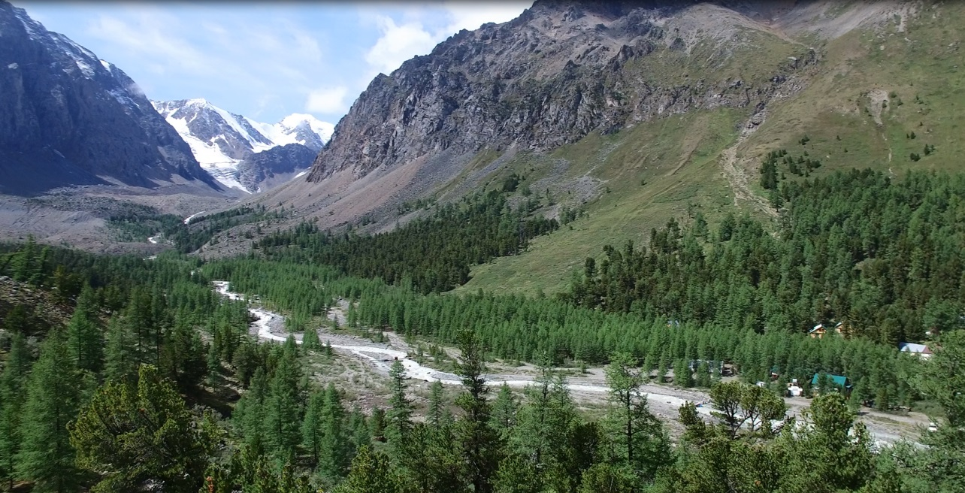

Coordinator

Liudmila Borilo – Professor, Doctor of Sciences,

Executive Director, TSSW,

National Research Tomsk State University

Tel.: +73822 52 98 24

Managers

Anastasiya Larionova

Darya Chernikova

E-mail: chdv@mail.tsu.ru Mob.: +7 913 827 57 91

